<Execution Guidelines>

* CS410 Final Project, 2020, Fall
* Author : Changsoo Kim, Hongseok Ha

1. Prerequisites
   1. Python : version over 3.5
   2. Python packages : numpy, lda
   3. If you want to use np.load to load .npy files, please use numpy version 1.16.1
2. Data
   1. Default data(small, to upload git repository) directory : ‘./data/yelp_sanitation_data/’
   2. To try another dataset, please change line 16 of ‘Main.py’ file.
3. Output Example
   1. LDA output (5 topics)  
      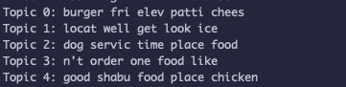
   2. LRR output  
        
      
4. Execution Steps
   1. Clone the repository
   2. Execute the Main.py, using command ‘python Main.py’
   3. If you want to change the LDA topic parameter (k),   
      please modify line 24 of ‘Main.py’ file. (n_topics)